TortoiseSVN's Settings
To find out what the different settings are for, just leave your mouse pointer a second on the editbox/checkbox... and a helpful tooltip will popup.

General Settings
Figure 4.51. The Settings Dialog, General Page
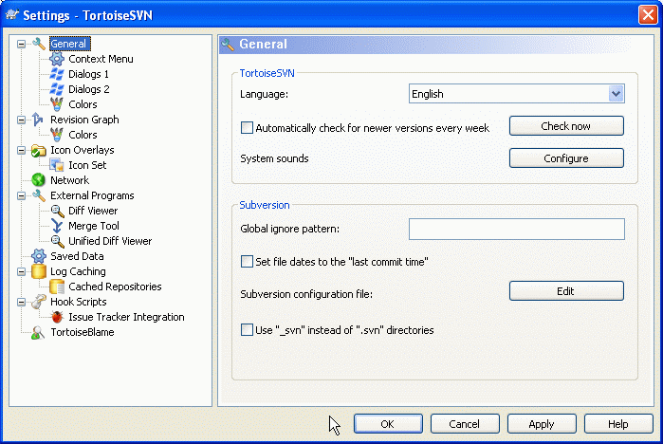
This dialog allows you to specify your preferred language, and the Subversion-specific settings.
Language
Selects your user interface language. What else did you expect?
Automatically check for newer versions every week
If checked, TortoiseSVN will contact its download site once a week to see if there is a newer version of the program available. Use Check now if you want an answer right away. The new version will not be downloaded; you simply receive an information dialog telling you that the new version is available.
System sounds
TortoiseSVN has three custom sounds which are installed by default.
- Error
- Notice
- Warning
You can select different sounds (or turn these sounds off completely) using the Windows Control Panel. Configure is a shortcut to the Control Panel.
Global ignore pattern
Global ignore patterns are used to prevent unversioned files from showing up e.g. in the commit dialog. Files matching the patterns are also ignored by an import. Ignore files or directories by typing in the names or extensions. Patterns are separated by spaces e.g. bin obj *.bak *.~?? *.jar *.[Tt]mp. These patterns should not include any path separators. Note also that there is no way to differentiate between files and directories. Read the section called “Pattern Matching in Ignore Lists” for more information on the pattern-matching syntax.
Note that the ignore patterns you specify here will also affect other Subversion clients running on your PC, including the command line client.

Caution
If you use the Subversion configuration file to set a global-ignores pattern, it will override the settings you make here. The Subversion configuration file is accessed using the Edit as described below.
This ignore pattern will affect all your projects. It is not versioned, so it will not affect other users. By contrast you can also use the versioned svn:ignore property to exclude files or directories from version control. Read the section called “Ignoring Files And Directories” for more information.
Set file dates to the “last commit time”
This option tells TortoiseSVN to set the file dates to the last commit time when doing a checkout or an update. Otherwise TortoiseSVN will use the current date. If you are developing software it is generally best to use the current date because build systems normally look at the date stamps to decide which files need compiling. If you use “last commit time” and revert to an older file revision, your project may not compile as you expect it to.
Subversion configuration file
Use Edit to edit the Subversion configuration file directly. Some settings cannot be modified directly by TortoiseSVN, and need to be set here instead. For more information about the Subversion config file see the Runtime Configuration Area . The section on Automatic Property Setting is of particular interest, and that is configured here. Note that Subversion can read configuration information from several places, and you need to know which one takes priority. Refer to Configuration and the Windows Registry to find out more.
Use _svn instead of .svn directories
VS.NET when used with web projects can't handle the .svn folders that Subversion uses to store its internal information. This is not a bug in Subversion. The bug is in VS.NET and the frontpage extensions it uses. Read the section called “Subversion Working Folders” to find out more about this issue.
If you want to change the behaviour of Subversion and TortoiseSVN, you can use this checkbox to set the environment variable which controls this.
You should note that changing this option will not automatically convert existing working copies to use the new admin directory. You will have to do that yourself using a script (See our FAQ) or simply check out a fresh working copy.

Context Menu Settings
Figure 4.52. The Settings Dialog, Context Menu Page
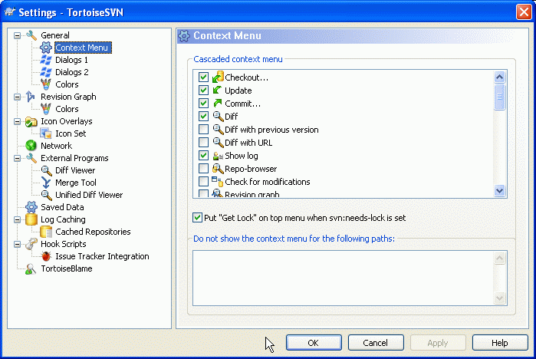
This page allows you to specify which of the TortoiseSVN context menu entries will show up in the main context menu, and which will appear in the TortoiseSVN submenu. By default most items are unchecked and appear in the submenu.
There is a special case for Get Lock. You can of course promote it to the top level using the list above, but as most files don't need locking this just adds clutter. However, a file with the svn:needs-lock property needs this action every time it is edited, so in that case it is very useful to have at the top level. Checking the box here means that when a file is selected which has the svn:needs-lock property set, Get Lock will always appear at the top level.
If there are some paths on your computer where you just don't want TortoiseSVN's context menu to appear at all, you can list them in the box at the bottom.

TortoiseSVN Dialog Settings 1
Figure 4.53. The Settings Dialog, Dialogs 1 Page
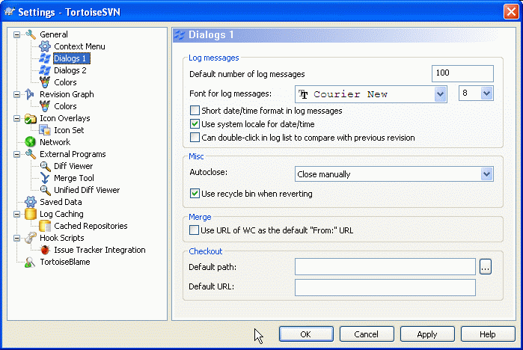
This dialog allows you to configure some of TortoiseSVN's dialogs the way you like them.
Default number of log messages
Limits the number of log messages that TortoiseSVN fetches when you first select TortoiseSVN → Show Log Useful for slow server connections. You can always use Show All or Next 100 to get more messages.
Font for log messages
Selects the font face and size used to display the log message itself in the middle pane of the Revision Log dialog, and when composing log messages in the Commit dialog.
Short date / time format in log messages
If the standard long messages use up too much space on your screen use the short format.
Can double-click in log list to compare with previous revision
If you frequently find yourself comparing revisions in the top pane of the log dialog, you can use this option to allow that action on double-click. It is not enabled by default because fetching the diff is often a long process, and many people prefer to avoid the wait after an accidental double-click, which is why this option is not enabled by default.
Progress Dialog
TortoiseSVN can automatically close all progress dialogs when the action is finished without error. This setting allows you to select the conditions for closing the dialogs. The default (recommended) setting is Close manually which allows you to review all messages and check what has happened. However, you may decide that you want to ignore some types of message and have the dialog close automatically if there are no critical changes.
Auto-close if no merges, adds or deletes means that the progress dialog will close if there were simple updates, but if changes from the repository were merged with yours, or if any files were added or deleted, the dialog will remain open. It will also stay open if there were any conflicts or errors during the operation.
Auto-close if no merges, adds or deletes for local operations means that the progress dialog will close as for Auto-close if no merges, adds or deletes but only for local operations like adding files or reverting changes. For remote operations the dialog will stay open.
Auto-close if no conflicts relaxes the criteria further and will close the dialog even if there were merges, adds or deletes. However, if there were any conflicts or errors, the dialog remains open.
Auto-close if no errors always closes the dialog even if there were conflicts. The only condition that keeps the dialog open is an error condition, which occurs when Subversion is unable to complete the task. For example, an update fails because the server is inaccessible, or a commit fails because the working copy is out-of-date.
Use recycle bin when reverting
When you revert local modifications, your changes are discarded. TortoiseSVN gives you an extra safety net by sending the modified file to the recycle bin before bringing back the pristine copy. If you prefer to skip the recycle bin, uncheck this option.
Use URL of WC as the default “From:” URL
In the merge dialog, the default behaviour is for the From: URL to be remembered between merges. However, some people like to perform merges from many different points in their hierarchy, and find it easier to start out with the URL of the current working copy. This can then be edited to refer to a parallel path on another branch.
Default checkout path
You can specify the default path for checkouts. If you keep all your checkouts in one place, it is useful to have the drive and folder pre-filled so you only have to add the new folder name to the end.
Default checkout URL
You can also specify the default URL for checkouts. If you often checkout sub-projects of some very large project, it can be useful to have the URL pre-filled so you only have to add the sub-project name to the end.

TortoiseSVN Dialog Settings 2
Figure 4.54. The Settings Dialog, Dialogs 2 Page
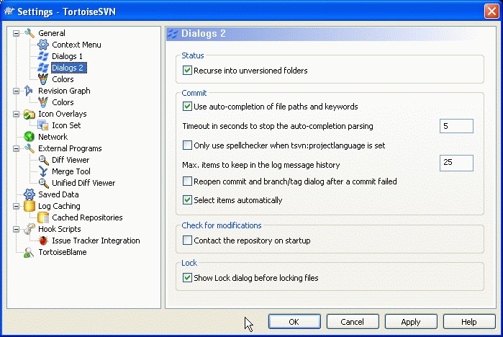

Recurse into unversioned folders
If this box is checked (default state), then whenever the status of an unversioned folder is shown in the Add, Commit or Check for Modifications dialog, every child file and folder is also shown. If you uncheck this box, only the unversioned parent is shown. Unchecking reduces clutter in these dialogs. In that case if you select an unversioned folder for Add, it is added recursively.
Use auto-completion of file paths and keywords
The commit dialog includes a facility to parse the list of filenames being committed. When you type the first 3 letters of an item in the list, the auto-completion box pops up, and you can press Enter to complete the filename. Check the box to enable this feature.
Timeout in seconds to stop the auto-completion parsing
The auto-completion parser can be quite slow if there are a lot of large files to check. This timeout stops the commit dialog being held up for too long. If you are missing important auto-completion information, you can extend the timeout.
Only use spellchecker when tsvn:projectlanguage is set
If you don't wish to use the spellchecker for all commits, check this box. The spellchecker will still be enabled where the project properties require it.
Max. items to keep in the log message history
When you type in a log message in the commit dialog, TortoiseSVN stores it for possible re-use later. By default it will keep the last 25 log messages for each repository, but you can customize that number here. If you have many different repositories, you may wish to reduce this to avoid filling your registry.
Note that this setting applies only to messages that you type in on this computer. It has nothing to do with the log cache.
Re-open commit and branch/tag dialog after a commit failed
When a commit fails for some reason (working copy needs updating, pre-commit hook rejects commit, network error, etc), you can select this option to keep the commit dialog open ready to try again. However, you should be aware that this can lead to problems. If the failure means you need to update your working copy, and that update leads to conflicts you must resolve those first.
Select items automatically
The normal behaviour in the commit dialog is for all modified (versioned) items to be selected for commit automatically. If you prefer to start with nothing selected and pick the items for commit manually, uncheck this box.
Contact the repository on startup
The Check for Modifications dialog checks the working copy by default, and only contacts the repository when you click Check repository. If you always want to check the repository, you can use this setting to make that action happen automatically.
Show Lock dialog before locking files
When you select one or more files and then use TortoiseSVN → Lock to take out a lock on those files, on some projects it is customary to write a lock message explaining why you have locked the files. If you do not use lock messages, you can uncheck this box to skip that dialog and lock the files immediately.
If you use the lock command on a folder, you are always presented with the lock dialog as that also gives you the option to select files for locking.
If your project is using the tsvn:lockmsgminsize property, you will see the lock dialog regardless of this setting because the project requires lock messages.

TortoiseSVN Colour Settings
Figure 4.55. The Settings Dialog, Colours Page
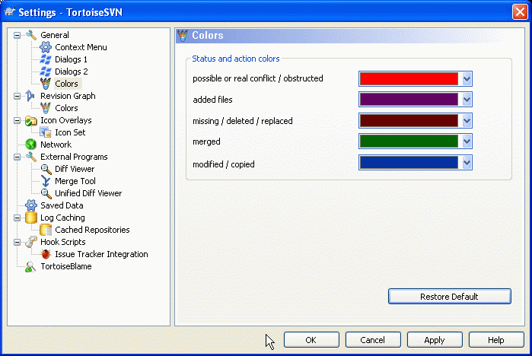
This dialog allows you to configure the text colours used in TortoiseSVN's dialogs the way you like them.
Possible or real conflict / obstructed
A conflict has occurred during update, or may occur during merge. Update is obstructed by an existing unversioned file/folder of the same name as a versioned one.
This colour is also used for error messages in the progress dialogs.
Added files
Items added to the repository.
Missing / deleted / replaced
Items deleted from the repository, missing from the working copy, or deleted from the working copy and replaced with another file of the same name.
Merged
Changes from the repository successfully merged into the WC without creating any conflicts.
Modified / copied
Add with history, or paths copied in the repository. Also used in the log dialog for entries which include copied items.
Deleted node
An item which has been deleted from the repository.
Added node
An item which has been added to the repository, by an add, copy or move operation.
Renamed node
An item which has been renamed within the repository.
Replaced node
The original item has been deleted and a new item with the same name replaces it.

